PRACTICAL 4- WIKIPEDIA, ACCOUNT CREATING, CREATING PAGE AND EDITING IT.

1. What is Wikipedia?

Ans- Wikipedia is a free content, multilingual online encyclopaedia written and maintained by a community of volunteers through a model of open collaboration, using a wiki-based editing system. Individual contributors, also called editors, are known as Wikipedia’s. It is the largest and most- read reference work in history.

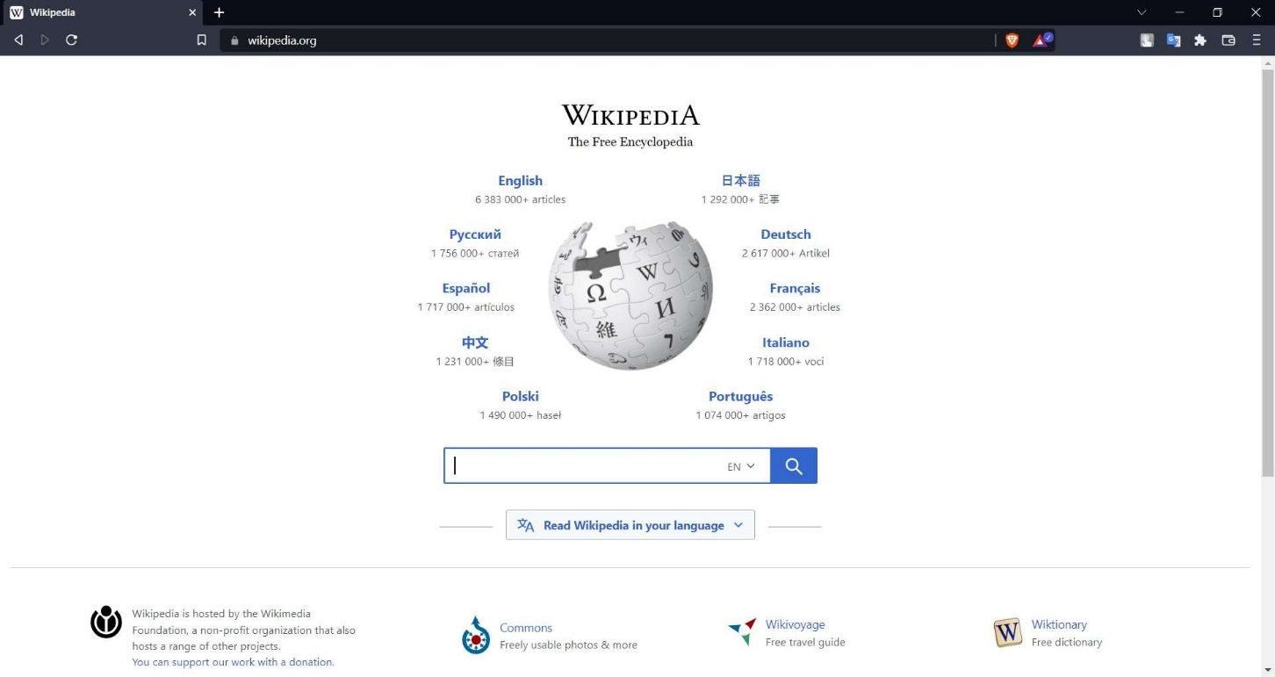

1. Creating an Account.

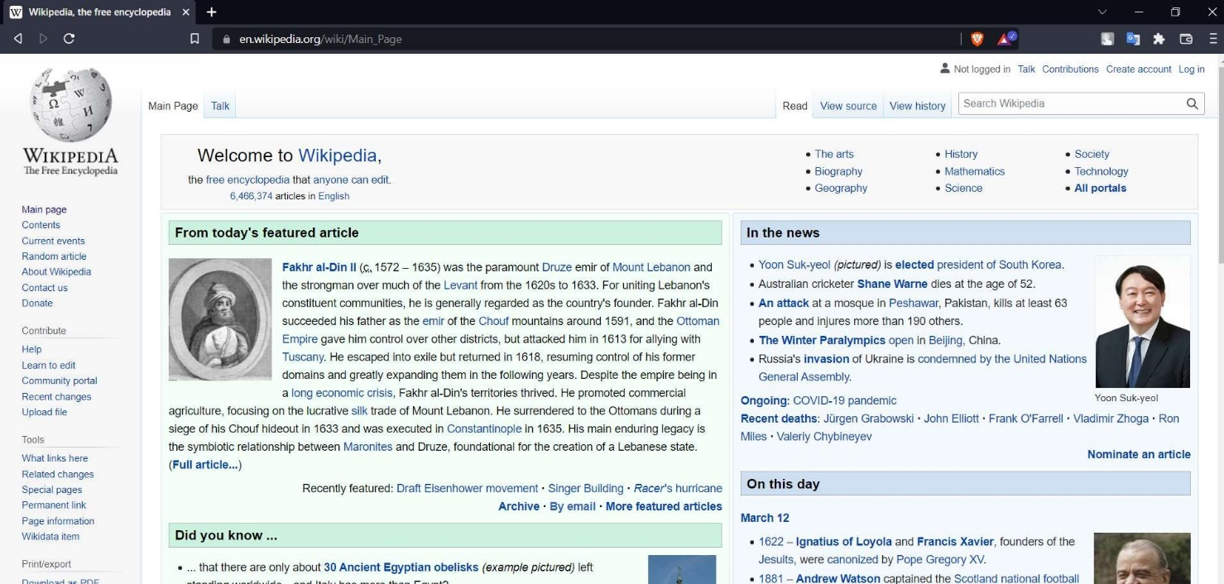

Step 1) Click on the <create account> button.

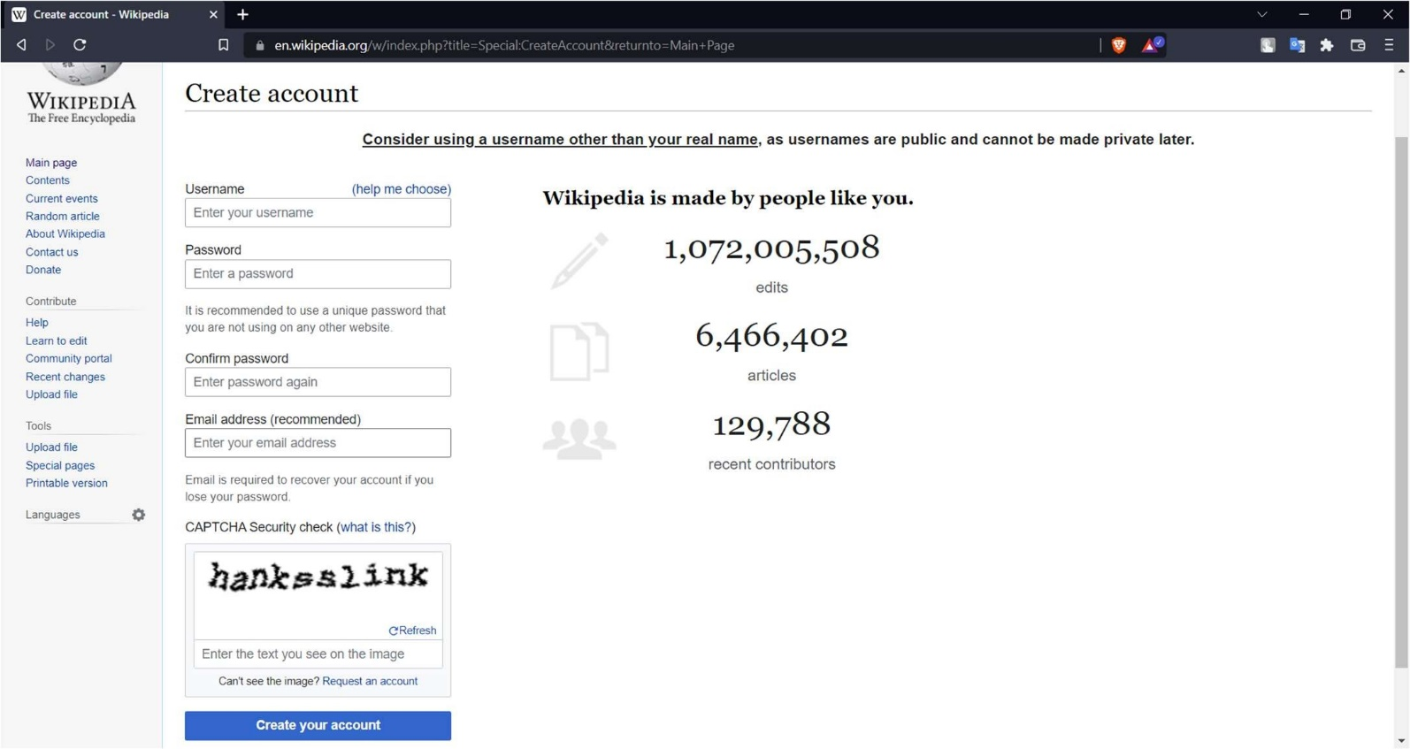

Fill in the details.

.

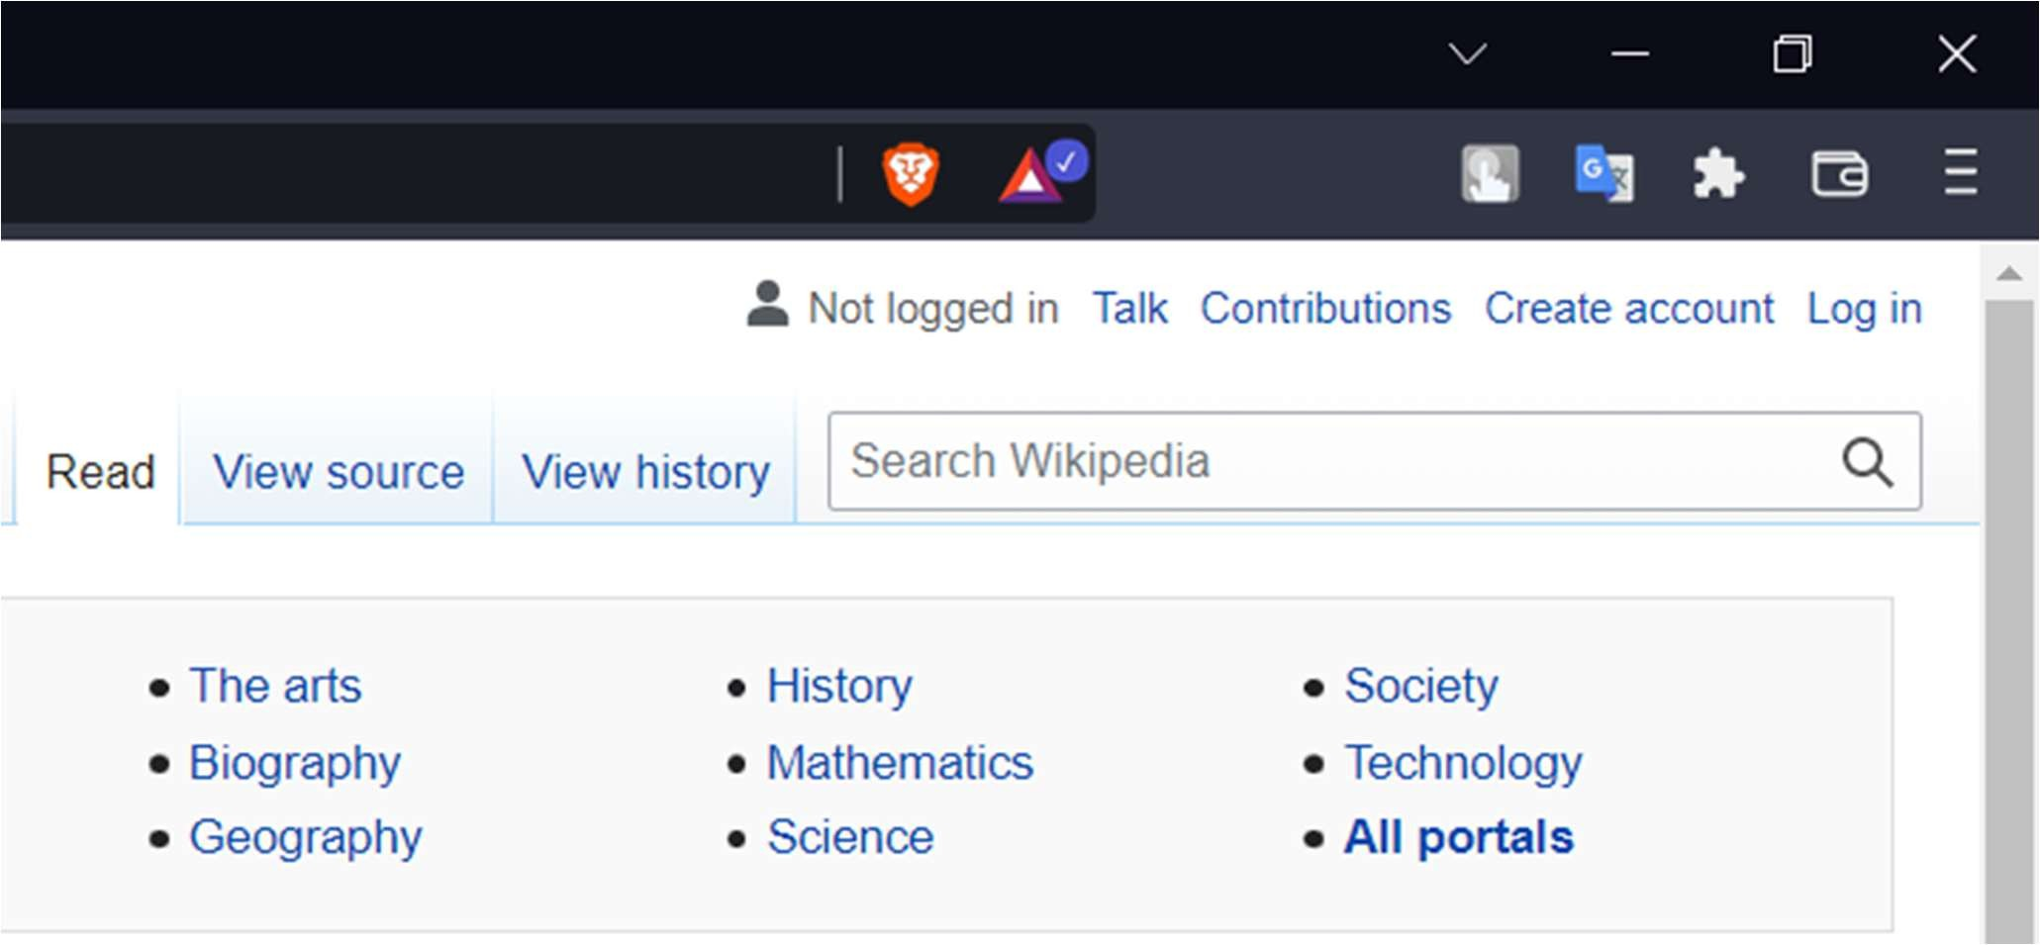

Step 2) After clicking there you will be given a form;

Step 3) Fill in the form and give the respected credential it asks . After that click on the <create your account> button.

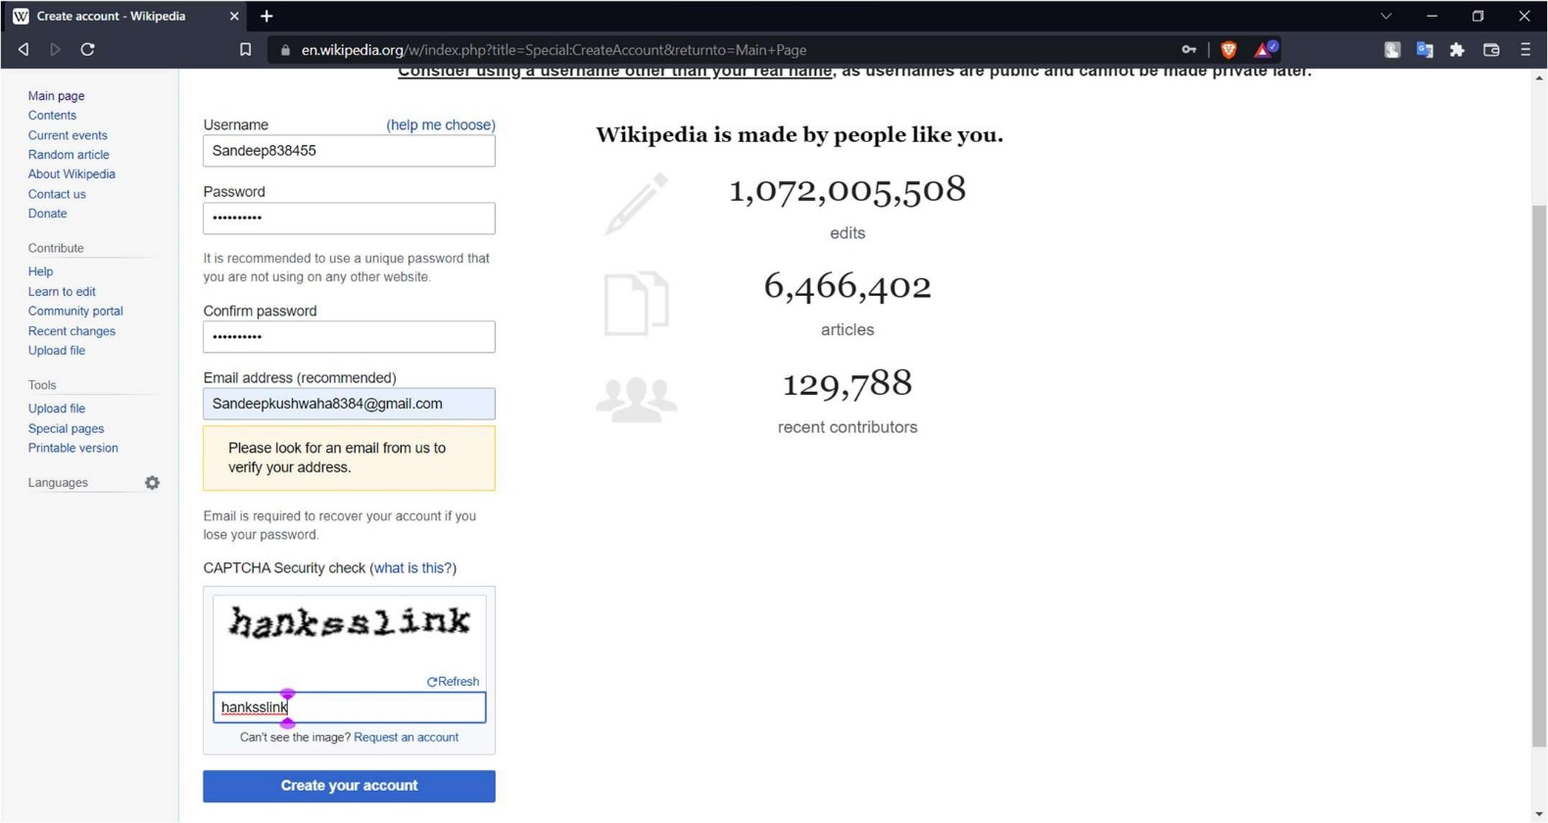

Click here.

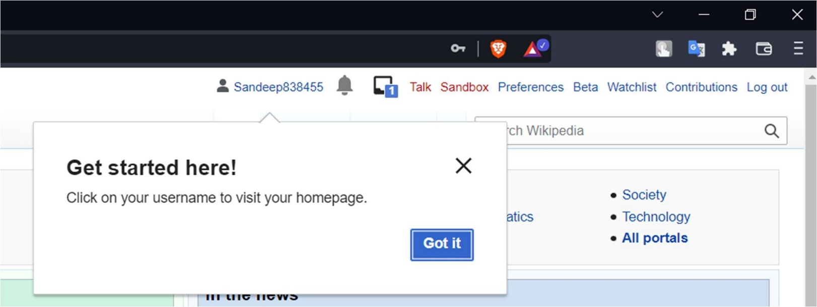

Once you are done it will show a popup and now your account is created.

1. Creating Your Page.

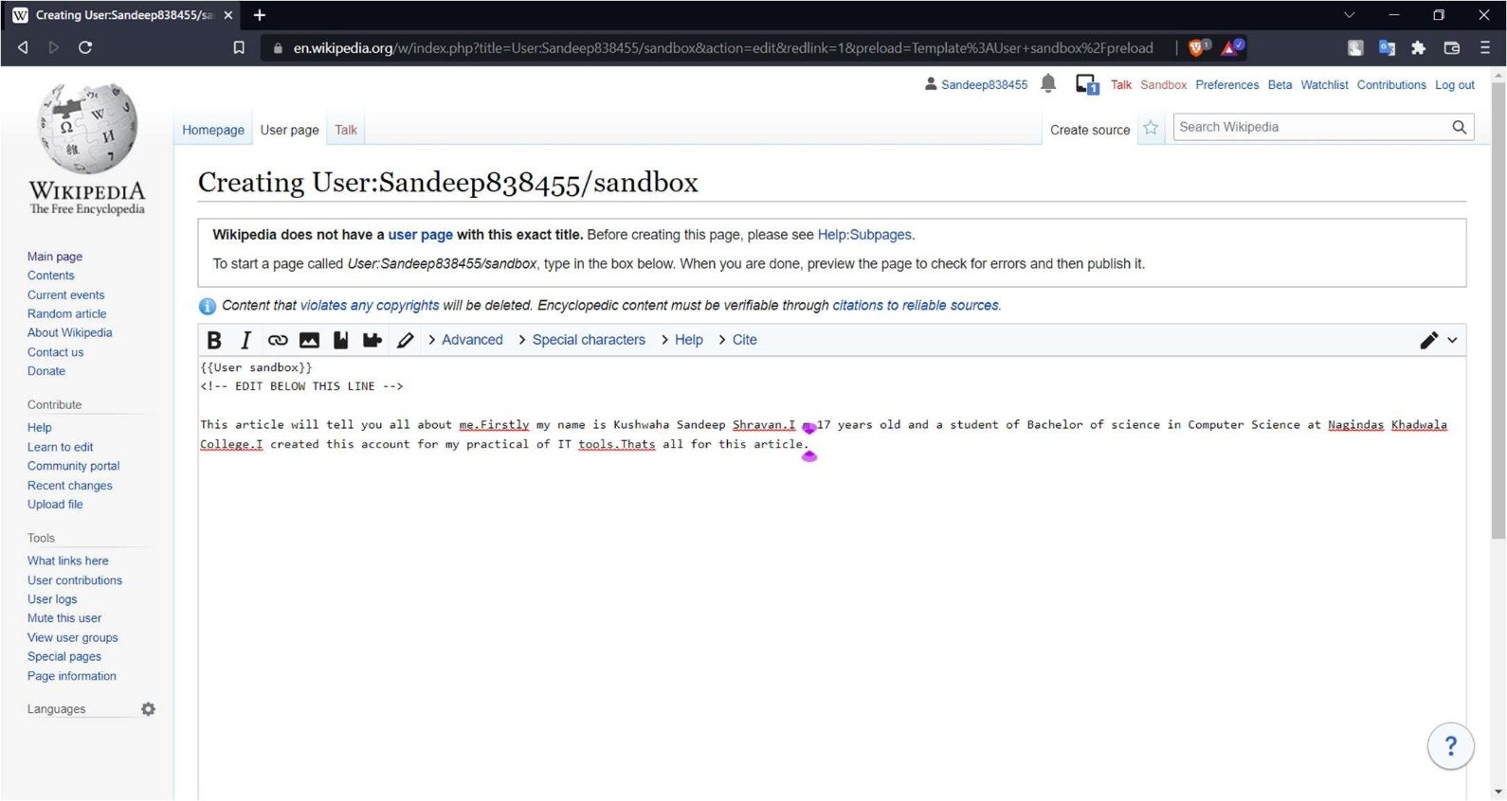

Free space to write and edit article,

Step 1) Click on the <sandbox> button.

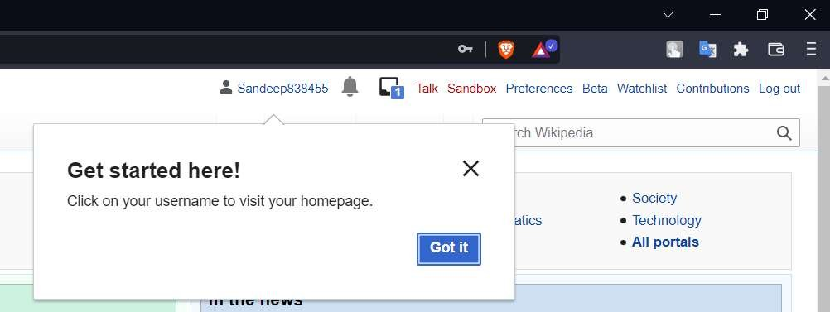

Step 2)After clicking on it, it will take you to this page to write your articles.

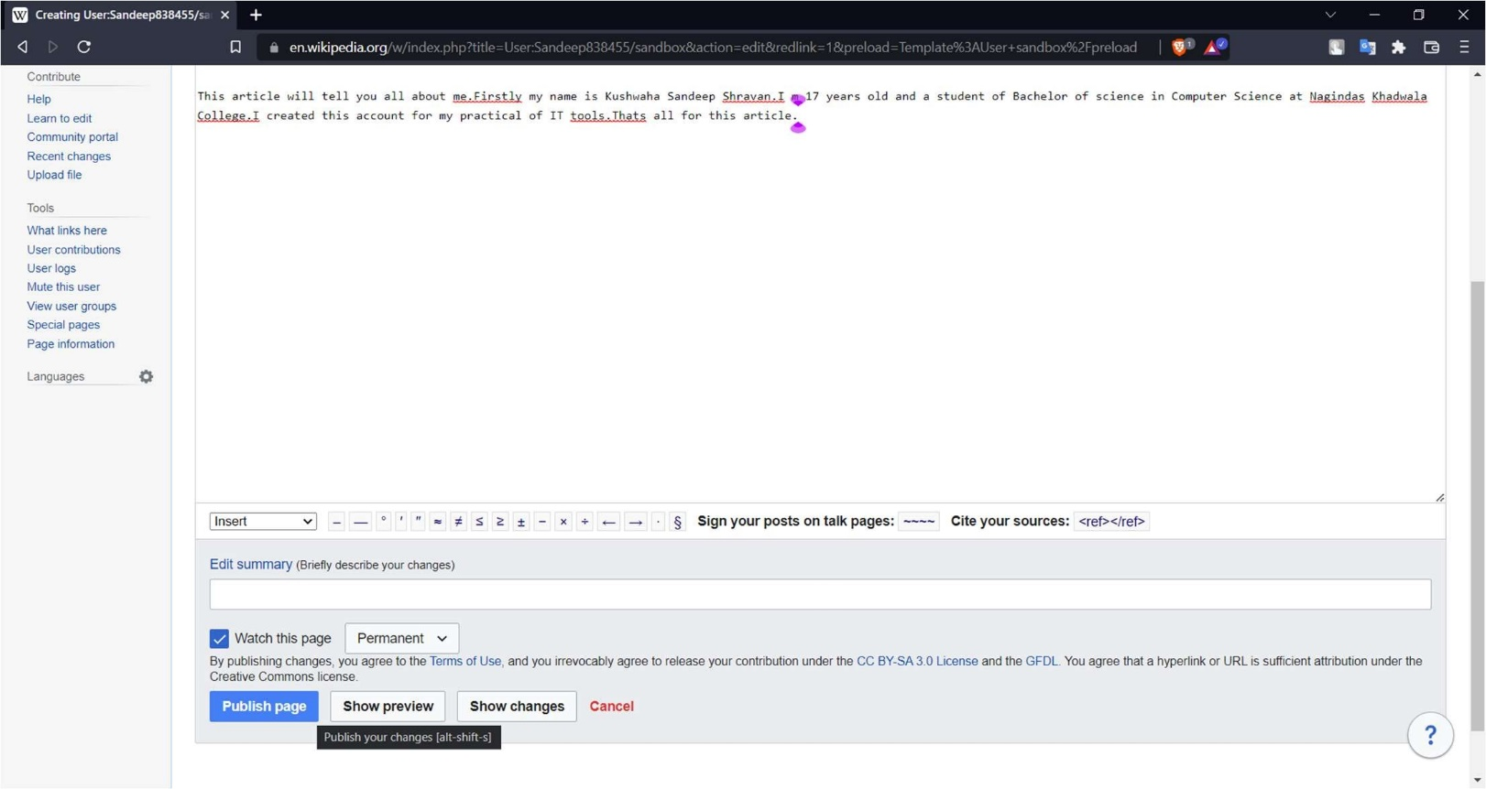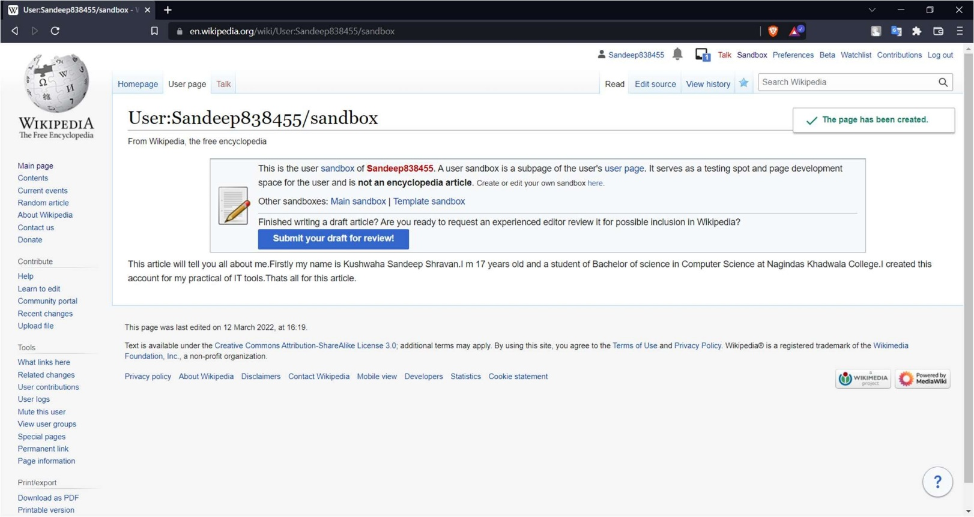

Step 3) Write the article u wanna publish.

Step 4) Click on “Submit your draft for review” option if you have created a draft.

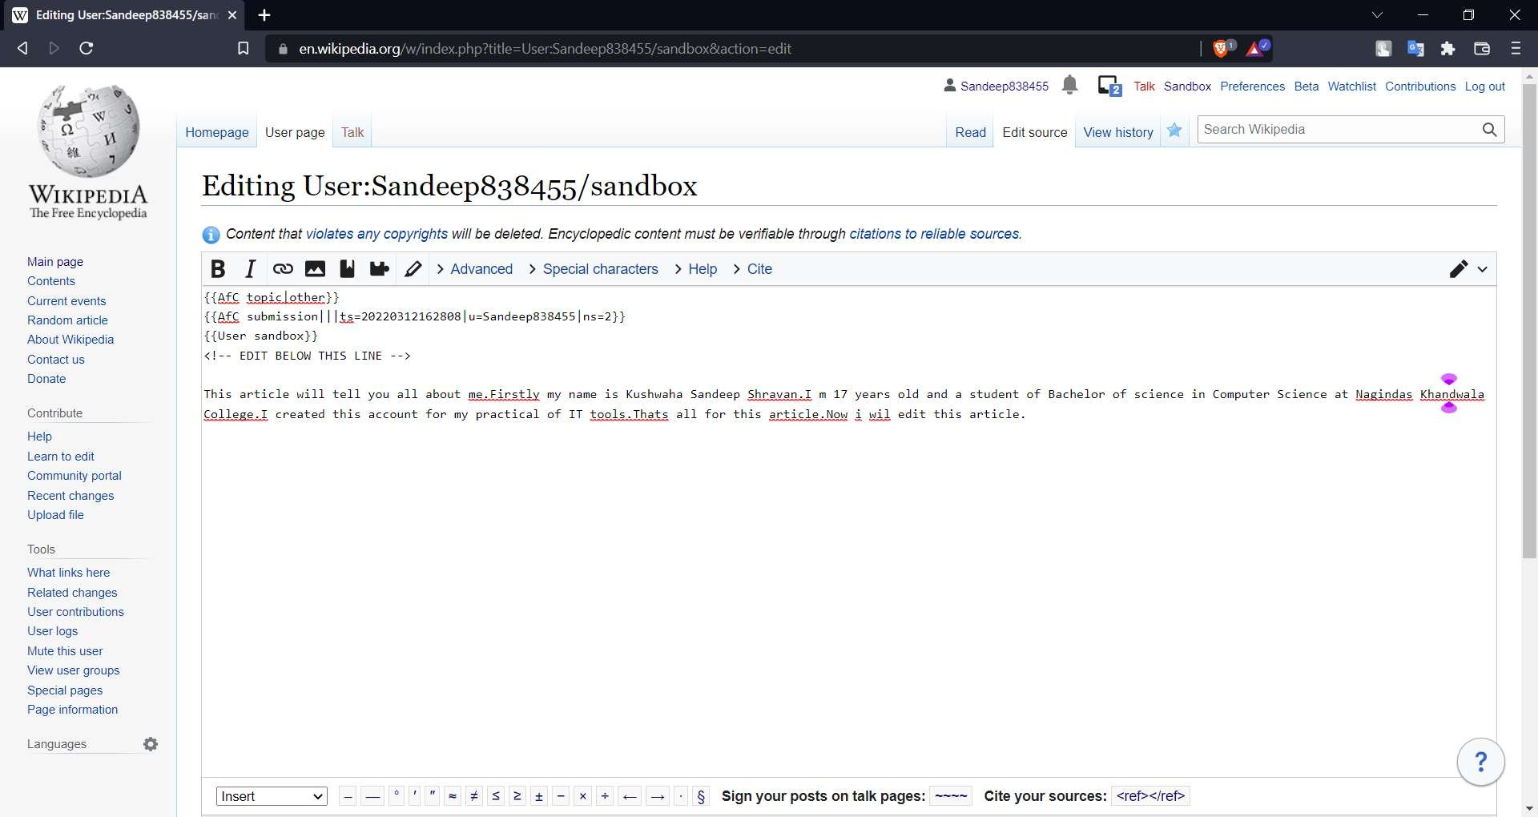

Editing the text

1. Edit your page

Step 1) To edit your page content click on the <edit source> button and edit your content.

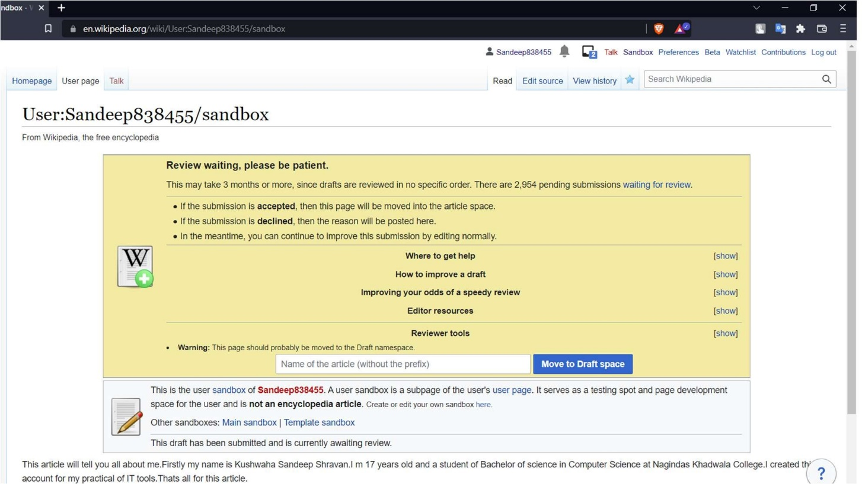

Step 2) A page like below will appear where you can edit your content and republish it.

After that just republish the changes.

